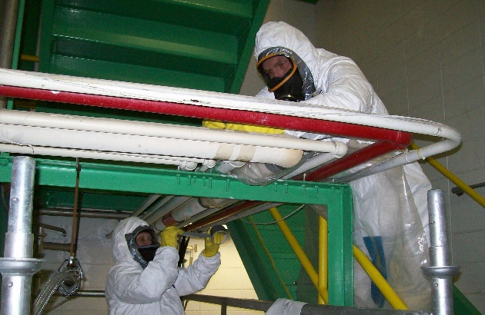

Business Overview

**RE: Environmental Based Services - Lead, Mold & Asbestos**

A 12.5% down payment of $681,250 returns $691,301 in the first year after debt payments! The seller is willing to hold 15% of the note and is willing to do either a seller carry or equity hold for that amount. With a team of 90+ employees, this company allows for passive ownership. The team of well-trained specialists provide exceptional asbestos abatement, lead and mold remediation services. With most projects one to two weeks in duration, this company completes 800 jobs per year. Annually, there are typically one or two very large projects that bring in over 10% of income, but the projects and customers vary from year-to-year. The diverse customer base includes industrial businesses (<5%), commercial companies (90%) and homeowners (<10%).

Leveraging their $3,004,099 in assets as well as their team of 75 union workers, this well-established company is efficient, driven, and well-respected for their industry knowledge. They are often called upon to successfully complete projects that others consider exceedingly technical, challenging, or too large. Located in a large facility, the warehouse has storage space for all equipment and inventory, while the office can house the 17-member administrative team comfortably. This location will be for sale outside the sale of the business.

The owners are not involved in the day-to-day operations, rather lending their skills to business analysis, financial management, and process improvement.

**Business Highlights**

* **Year Established:** 1980’s
* **Location:** Twin Cities
* **Service Area:** Minnesota and Illinois
* **Clients:** General contractors, building owners, environmental consultants; Industrial (<5%) commercial (90%), residential (<10%)
* **Services:** Asbestos abatement, lead and mold remediation
* **Building:** Large facility with 25% allocated to office space and 75% warehouse with loading dock, additional storage on-site - The building will be available for sale outside the sale of the business.
* **Reason for Selling:** Focus on non-competing ventures
* **Employees:** 90+: 17 Administrative, 75 union employees in the field
* **Seller Training Period:** 1-2 years
* **Growth Opportunities:** Grow industrial market, expand into fire and water restoration and explore emergency management
* **Current Owners’ Responsibilities:** Passive Ownership: financial review and business improvement

**Financial Highlights**

* List Price: $5,450,000
* Gross Sales:
  + 2019: $12,089,740
* Cash Flow:
  + 2019: $1,451,295
  + 2018: $1,003,690
  + 2017: $1,037,175
* Assets: $3,004,099
  + Equipment: Equipment, job site materials, safety equipment, tools
  + Vehicles: 12 trucks
  + Intangible Assets: Industry experts, excellent brand reputation, compliant processes

*\*amounts may vary, replacement value*

**Cash Flow Analysis**



Profit Margin: 12%

**Typical Clients and Services**

Clients:

* Industrial (<5%)
* Commercial (90%)
* Residential (<10%)

Services

* Asbestos abatement
* Selective demolition
* Lead and mold remediation
* HVAC Cleaning
* Specialty Cleaning

*Specific information regarding clients is available upon the receipt of a signed Non-Disclosure Agreement.*

**Employees**

Total Employees: 90+

* 17 Administrative
  + 4 Executives
  + 5 Project managers
  + 4 Managers and Leads
  + 4 Administration
* 75 Union Employees in the Field

**Growth Opportunities**

* Grow the demolition division
* Expand into fire and water restoration
* Explore emergency management services
* Insurance partnerships
* Exterior restoration
* Grow industrial market
* Leverage secondary location for additional services

**Valuation Details**

The Firm used a *cash flow valuation* methodology to determine the purchase price of the business.

The formula used is as follows:

Cash Flow x Prescribed Multiple = Fair Market Value

Cash flow is the sum of business net income plus any owner perks and any non-onward going expenses.

A multiple is prescribed by a 20 question, 100-point parameter ranking system that is used to analyze the current business health. Each question is based on a scale from 1 to 5: 1 being low, 2 below average, 3 average, 4 above average, 5 high. The average of the responses sum is the business’ prescribed multiple.

For this business, the 2019 cash flow was used with a prescribed multiple of 3.75. With this information, the computation is as follows:

$1,456,295 x 3.75 = $5,461,106

The *fair market value* found above positions the business list price at **$5,450,000**.

**Funding Example**

**Purchase Price: $5,450,000**

*12.5%* **Buyer Down Payment:** $681,250

*12.5%* **Seller Financing**

**or Equity Roll:** $681,250

*75%* **Bank Loan:** $4,087,500

Seller financing 6-year term at a rate of 6.0% equals a monthly loan payment of $10,034.

Bank loan 8-year term at a rate of 6% equals a monthly loan payment of $53,716.

After business expenses and loan payments, a buyer with a 12.5% down payment of $681,250 would retain a profit of $691,301, which results in an 101% return on investment in the first year.

A lender is required to have a minimum 1.5 coverage ratio for any business loans extended. At a proposed purchase price of $5,450,000 with the terms listed above, the coverage ratio is 1.9.

***Please note that the decision of whether to extend a loan on any sale belongs to the bank, and this document does not guarantee specific terms or verify that financing is available.***

**\*\*The Firm Business Brokerage is not a real estate brokerage and therefore the staff will not handle any aspect of the lease, sale or purchase of real estate.\*\***

**Attachments**

* Business Summary
  + - Identifies important business information in an organized, quick-reference format
* Cash Flow Analysis
  + - The owner’s profit is the sum of business net income, any owner’s perks, & any non-onward going expenses (cash flow)